M2M Wi-Fi Module
Web Configuration Service
User Guide
Release 1.0
September 2026

Document Revision History
Version | Date | Changes
1.0 | 2026-09 | Initial release — covers the 8-screen web configuration UI (Status, Wi-Fi, Enterprise, IP Settings, MQTT Broker, TLS Certificates, Firmware, About).

Table of Contents
Right-click and choose Update Field to build the table of contents.

1. Introduction
The M2M Wi-Fi module includes a built-in configuration website. Once the module is connected to your network, you can open this website from any computer or phone on the same network to check its status and change its settings — no additional software or mobile app is required.
This guide walks through every screen of that website: what it shows, and what each button and field does.

2. Getting Started

2.1 Finding the Device's IP Address
Every device on your network is assigned an IP address — a set of four numbers such as 192.168.0.68. Your installer or network administrator can provide this address, or you can often find it listed by device name in your router's or access point's list of connected devices.

2.2 Opening the Web Page
With the module powered on and connected to your network, open a web browser on any computer or phone on the same network and enter the device's address, for example:
http://192.168.0.68/
Enter the address exactly as shown, starting with http:// — the page is only available over plain HTTP, not HTTPS.

2.3 Logging In
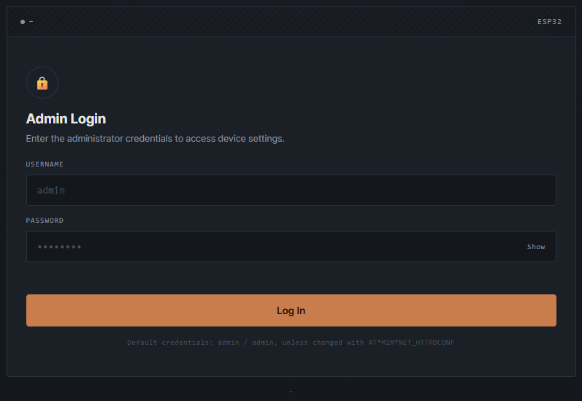
The login screen

The first time you open the page, you'll see the login screen shown above. Enter the administrator username and password, then select Log In.

On This Screen
- Username — the administrator account name. Unless your installer has changed it, this is admin.
- Password — the administrator account password. The default is also admin; select Show to reveal what you've typed, or Hide to mask it again.
- Log In — submits the credentials above. If they're rejected, an error message appears next to the password field and the box is outlined in red.
For security, ask your installer to change the default password before the device goes into regular use. Once you're logged in, your session stays open until you select Log out in the top-right corner.

3. Screens
After logging in, every screen is listed on the left. Select any item to switch screens.

3.1 Status
Status opens automatically after login and is the best place to check whether the module is online and connected.
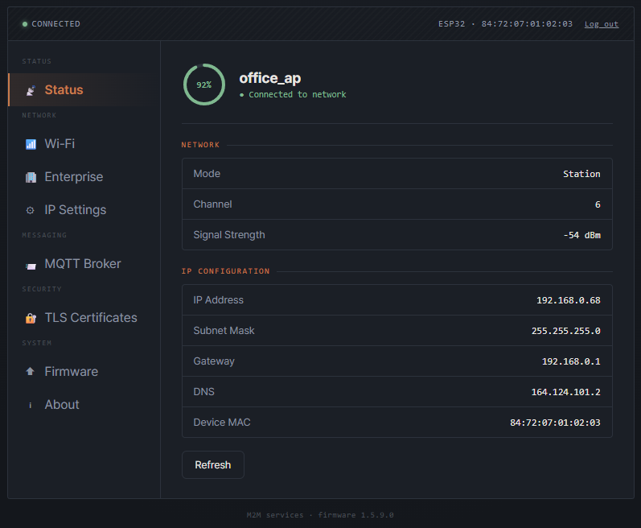
Status — connected to a Wi-Fi network

On This Screen
- Signal ring — a circular gauge showing Wi-Fi signal strength as a percentage, with the current network name beside it (or “SoftAP” if the module is broadcasting its own network instead of joining one).
- Network — the current Wi-Fi mode (Station or SoftAP), the channel in use, and the signal strength in dBm (Station mode only).
- IP Configuration — the module's IP address, subnet mask, gateway, DNS server, and Wi-Fi hardware (MAC) address.
- Refresh — reloads all the values on this screen immediately, without waiting for the next automatic update.

3.2 Wi-Fi
Use this screen to join a home or office Wi-Fi network that uses a single shared password. For a workplace or campus network that asks for a personal account instead, use the Enterprise screen described next.
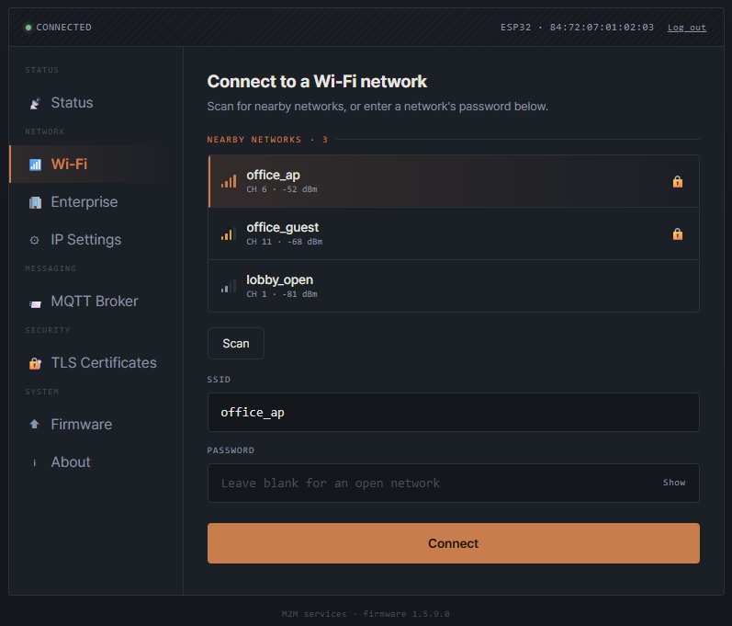
Wi-Fi — scan results with a network selected

On This Screen
- Nearby Networks — networks found by the most recent scan, each with a signal-strength icon and a lock icon for password-protected networks. Select a network to fill in its name below.
- Scan — searches for nearby Wi-Fi networks and refreshes the list above.
- SSID — the name of the network to join. Filled in automatically when you select a network above, or type it in directly — for example, for a hidden network.
- Password — the network's password. Leave this blank for an open network; select Show to check what you've typed.
- Connect — attempts to join the network entered above. A status message appears underneath; open the Status screen a few seconds later to confirm the connection succeeded.

3.3 Enterprise
Corporate or institutional networks often require a personal account rather than a single shared password — this is known as 802.1X or “WPA2/3-Enterprise” authentication. Use this screen to join that kind of network.
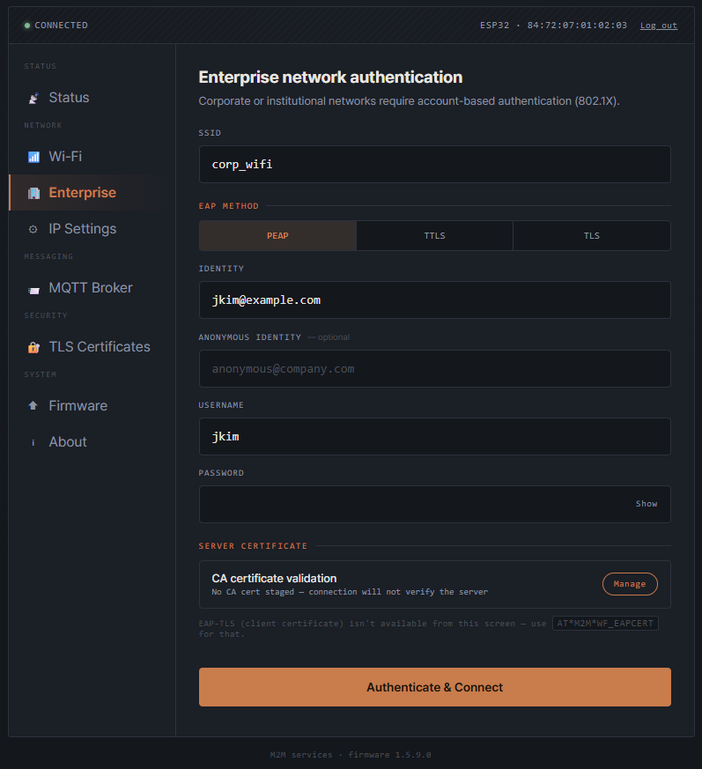
Enterprise — 802.1X network authentication

On This Screen
- SSID — the name of the enterprise network to join.
- EAP Method — the authentication protocol the network expects: PEAP, TTLS, or TLS. Your network administrator will tell you which one to select.
- Identity — the identity presented to the network before authentication begins.
- Anonymous Identity (optional) — an alternate identity shown to outside observers on networks that support it; leave this blank if you're unsure.
- Username / Password — your account credentials on the enterprise network.
- Server Certificate — shows whether a CA certificate has been uploaded (on the TLS Certificates screen) to verify the network's identity; select Manage to go there directly. A network that requires a certificate-only login instead of a username and password isn't configurable from this screen — ask your installer for help in that case.
- Authenticate & Connect — attempts to join the network using the settings above.

3.4 IP Settings
Most networks assign the module an address automatically. Use this screen only if your network administrator has asked you to set a fixed (static) address instead.
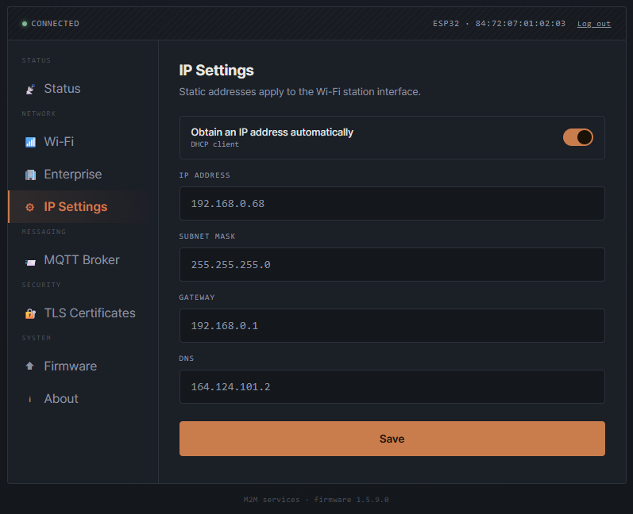
IP Settings — automatic addressing (DHCP), the default

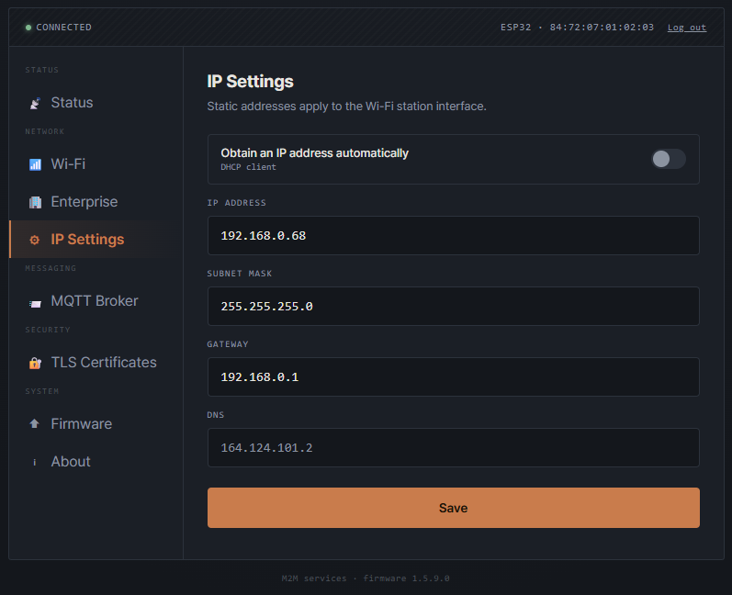
IP Settings — automatic addressing turned off, static fields enabled

On This Screen
- Obtain an IP address automatically — turns the DHCP client on or off. On (the default) hands out an address automatically; off enables the three fields below.
- IP Address / Subnet Mask / Gateway — only editable when the switch above is off; enter the values your network administrator provides.
- DNS — always read-only — it reflects the module's current DNS server and updates after you save.
- Save — applies the settings above immediately.

3.5 MQTT Broker
MQTT is a lightweight messaging service many M2M and IoT systems use to send device data to a cloud or local server (a “broker”). Use this screen to point the module at your broker.
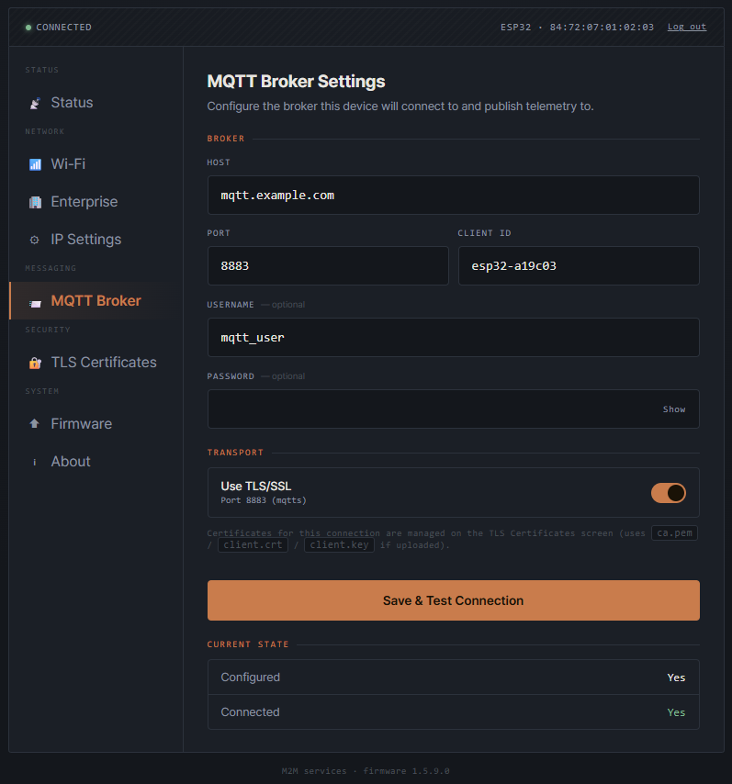
MQTT Broker — configured and connected over TLS

On This Screen
- Host / Port / Client ID — the address of the MQTT broker the module should connect to, its port, and the identifier the module presents to it.
- Username / Password (optional) — credentials for brokers that require a login.
- Use TLS/SSL — encrypts the connection to the broker and switches the default port between 1883 (plain) and 8883 (encrypted).
- Save & Test Connection — saves the settings and immediately attempts to connect; the result is reflected in Current State below.
- Current State — whether a broker is currently configured, and whether the module is connected to it right now.
Certificates for an encrypted connection are managed on the TLS Certificates screen, described next.

3.6 TLS Certificates
This screen manages the certificate files shared by an encrypted MQTT Broker connection and an Enterprise Wi-Fi connection.
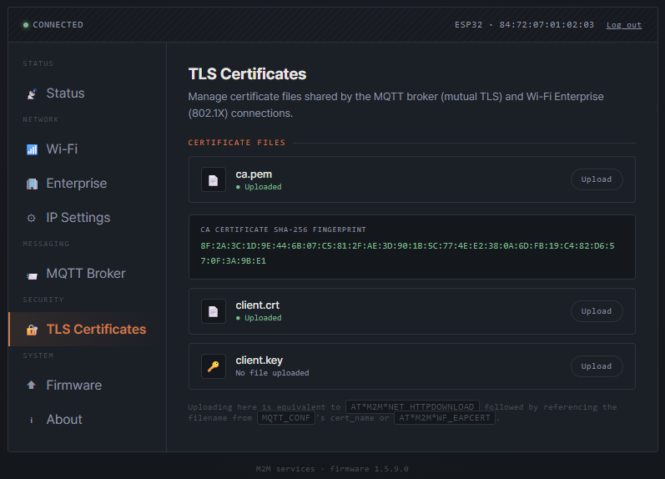
TLS Certificates — CA and client certificate uploaded

On This Screen
- ca.pem — the certificate authority file used to verify the broker or enterprise network you're connecting to.
- client.crt / client.key — this device's own certificate and private key, used only when a server requires a certificate from the module itself.
- Upload — choose a replacement file from your computer for that row. Each row shows Uploaded or No file uploaded for its current state.
- CA Certificate SHA-256 Fingerprint — appears once ca.pem is uploaded; compare it against the value your administrator gave you to confirm you uploaded the correct file.

3.7 Firmware
Use this screen to keep the device firmware current.
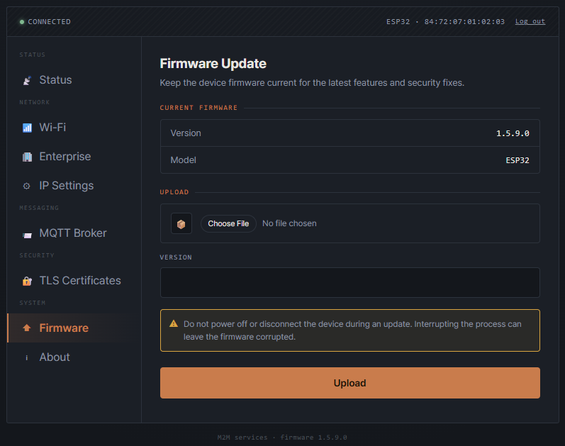
Firmware — current version and upload form

On This Screen
- Current Firmware — the version and model currently running on the device.
- Choose File — selects a firmware image file from your computer to upload.
- Version — the version number of the file you're uploading; it must be higher than the version currently running.
- Upload — sends the file to the device. Once it's written successfully, the module restarts automatically on the new firmware.
Do not power off or disconnect the device during an update.
Interrupting the process can leave the firmware corrupted, requiring the device to be serviced by your installer.

3.8 About
A simple information screen showing the device model and firmware version.
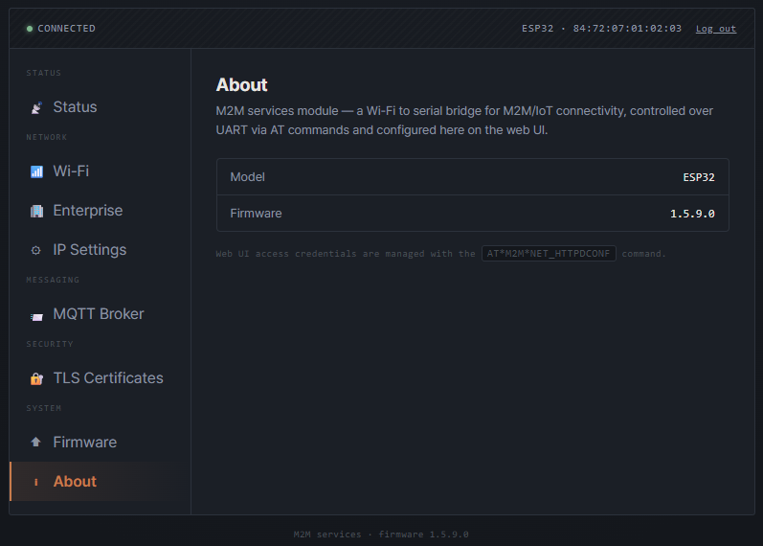
About

On This Screen
- Model / Firmware — the device model and the firmware version currently running.
Login credentials for this page are managed by your installer, using the module's serial command interface — they cannot be changed from the web page itself.

